Architecture Document

1. Introduction
This document outlines the architecture of the Multiple Disease Prediction System. The system leverages machine learning models to predict the likelihood of diabetes, heart disease, and Parkinson's disease based on user-provided medical parameters.
2. Architectural Approach
Selected Architecture: Microservices Architecture
Justification:
- The system consists of multiple independent services (such as user authentication, data processing, and model inference), making microservices the best fit.
- It enhances scalability, maintainability, and flexibility for future model integration.
- Each service can be independently deployed and updated.
3. System Components
3.1 Application Layer
- Frontend: Streamlit-based UI for user interaction.
- Backend: Flask API for handling requests and invoking machine learning models.
- Authentication Service: User login and session management.
- Prediction Service: Handles requests for model inference.
3.2 Data Layer
- Database: PostgreSQL for user data and logs.
- Model Storage: Trained models stored in a dedicated directory.
- ER Diagram:
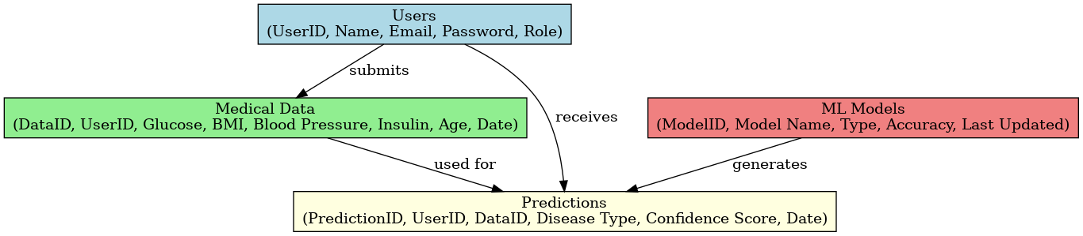

4. Data Flow & Communication
- User enters medical data on the UI.
- The backend processes the request and invokes the respective machine learning model.
- The model processes input and returns a prediction.
- Results are displayed to the user.
4.1 Data Exchange Contract
- Frequency of Data Exchange: On user request.
- Data Sets: Medical parameters including Glucose Level, BMI, Insulin Level, etc.
- Mode of Exchanges: REST API endpoints.
5. Diagrams
- Use Case Diagram
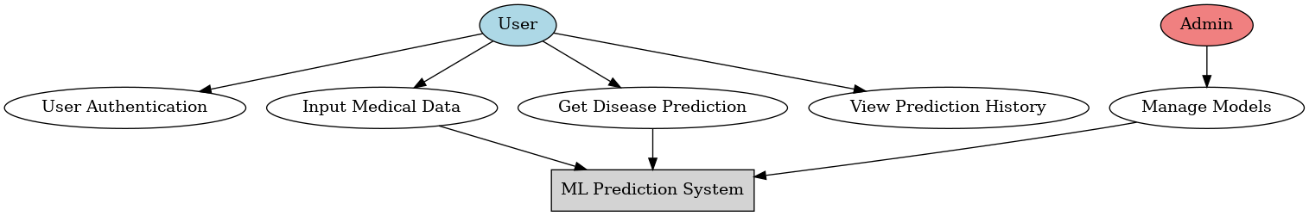
- Class Diagram
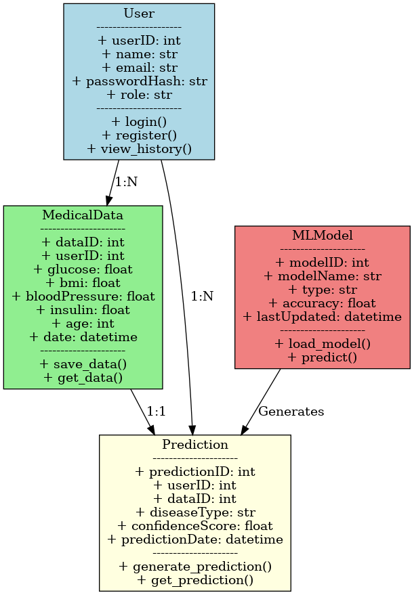
- DFD (Data Flow Diagram)
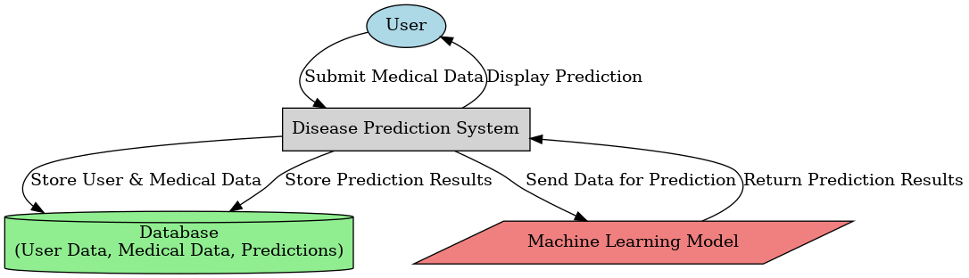
- Component Diagram
- 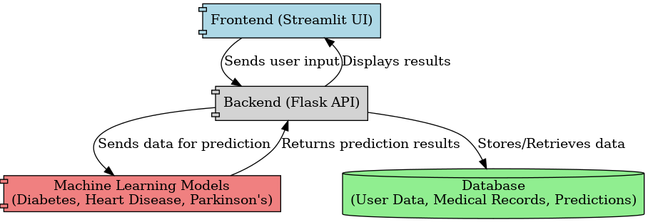

- Sequence Diagram

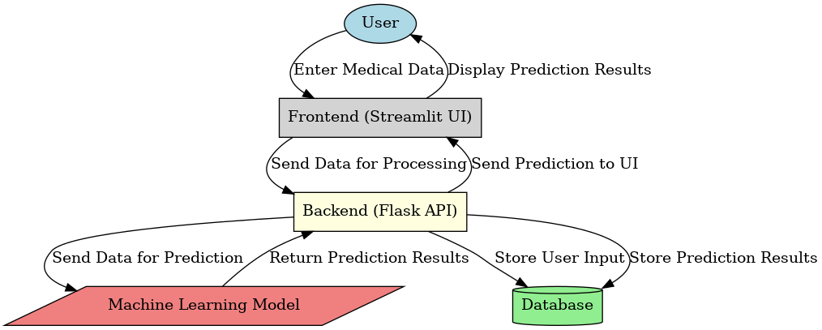

- Deployment Diagram
- 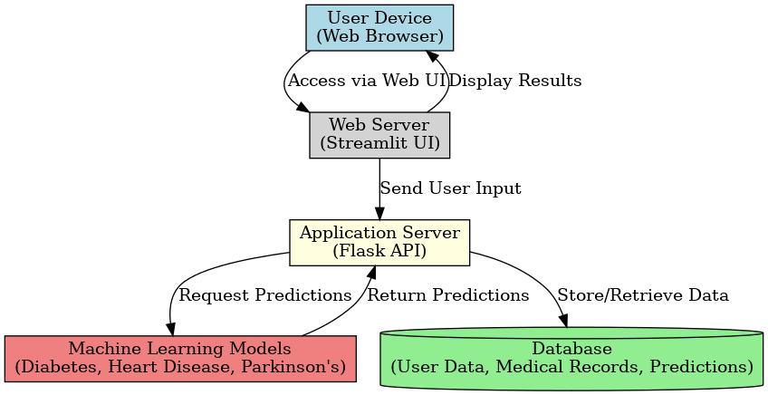

6. Conclusion
The Multiple Disease Prediction System is built on a microservices architecture, ensuring modularity, scalability, and maintainability. The system efficiently processes user input and delivers real-time disease predictions using machine learning models.

